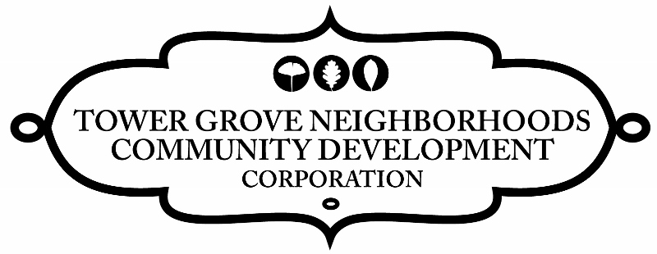
FOR IMMEDIATE RELEASE
Contact: Kristan Nickels
Phone: 314-865-5530
Email: Kristan@towergrovecdc.org
Website: TowerGroveCDC.org

What: Tower Grove Better Block
Who: Tower Grove Neighborhood Community Development Corporation organizer/host
Steve Ewing Band performance
Miss Jubilee and the Humdingers performance
Stray Rescue adoption event
Rock n’ Roll Craft Show local artisans/vendors
Local Artists, Vendors, Entertainers, Community Groups Full list below
When: Saturday, May 10th, 2014 12pm - 4pm
Where: 3200 Block of Morganford, St Louis Mo. 63116
How much: FREE

EVENT SUMMARY
On Saturday May 10, 2014 from 12:00pm to 4:00 p.m., Tower Grove Neighborhoods Community Development Corporation will host the Tower Grove Better Block Project to take place on the 3200 block of Morganford in Tower Grove South.

The Better Block project is a community planning exercise to show the potential to create a livable, vibrant, community. On May 10th, commercial vacancies will be brought to life with pop-up stores, restaurants and entertainment venues. The 3200 block of Morganford will be transformed to promote safe walkability and biking by installing bike “sharrows” and a permanent crosswalk. Outdoor café seating will be installed and a vacant lot will be transformed into public space that will offer classes and information on sustainability, as well as a Stray Rescue adoption event and a canned food drive benefitting Operation Food Search.
Better Block aims to create quick, inexpensive, high-impact changes that lead to permanent solutions for the area.

BETTER BLOCKS SUMMARY
“The Better Block project started in April 2010, when a group of community organizers, neighbors, and property owners gathered together to revitalize a single commercial block in an underused neighborhood corridor. The area was filled with vacant properties, wide streets, and few amenities for people who lived within walking distance. The group brought together all of the resources from the community and converted the block into a walkable, bikeable neighborhood destination for people of all ages complete with bike lanes, cafe seating, trees, plants, pop-up businesses, and lighting. The project was developed to show the city how the block could be revived and improve area safety, health, and economics if ordinances that restricted small business and multi-modal infrastructure were removed. Since that time, Better Block projects have been developed throughout the World with many of the temporary infrastructure improvements and businesses made permanent.” http://betterblock.org/

TOWER GROVE NEIGHBORHOODS COMMUNITY DEVELOPMENT CORPORATION SUMMARY
The Tower Grove Neighborhoods Community Development Corporation is a consolidation of Grand Oak Hill Community Corporation, Southwest Garden Housing Corporation and Shaw Neighborhood Housing Corporation. The three organizations have served the community for over 30 years. Now, as a combined entity, Tower Grove Neighborhoods Community Development Corporation continues the tradition and supports the area’s growth by promoting responsible development, affordable housing and diverse character and vibrancy in the neighborhoods surrounding Tower Grove Park. Tower Grove Neighborhoods Community Development Corporation is a 501(c)3 not for profit corporation.
http://towergrovecdc.org/ p.1

Tower Grove Better Block Press Release

FUNDING STATEMENT:
The Tower Grove Neighborhoods Community Development Corporation CDBG Neighborhood Improvement Program and related activities is financed wholly through a grant from the Department of Housing and Urban Development and the Community Development Administration under the provision of Title I of the Housing and Community Development Act of 1974 (Pub L, 93-383 42 USC 5301 et seq.) and/or HOME Title II of the National Affordable Housing Act of 1990, as amended (Public Law 101-625)

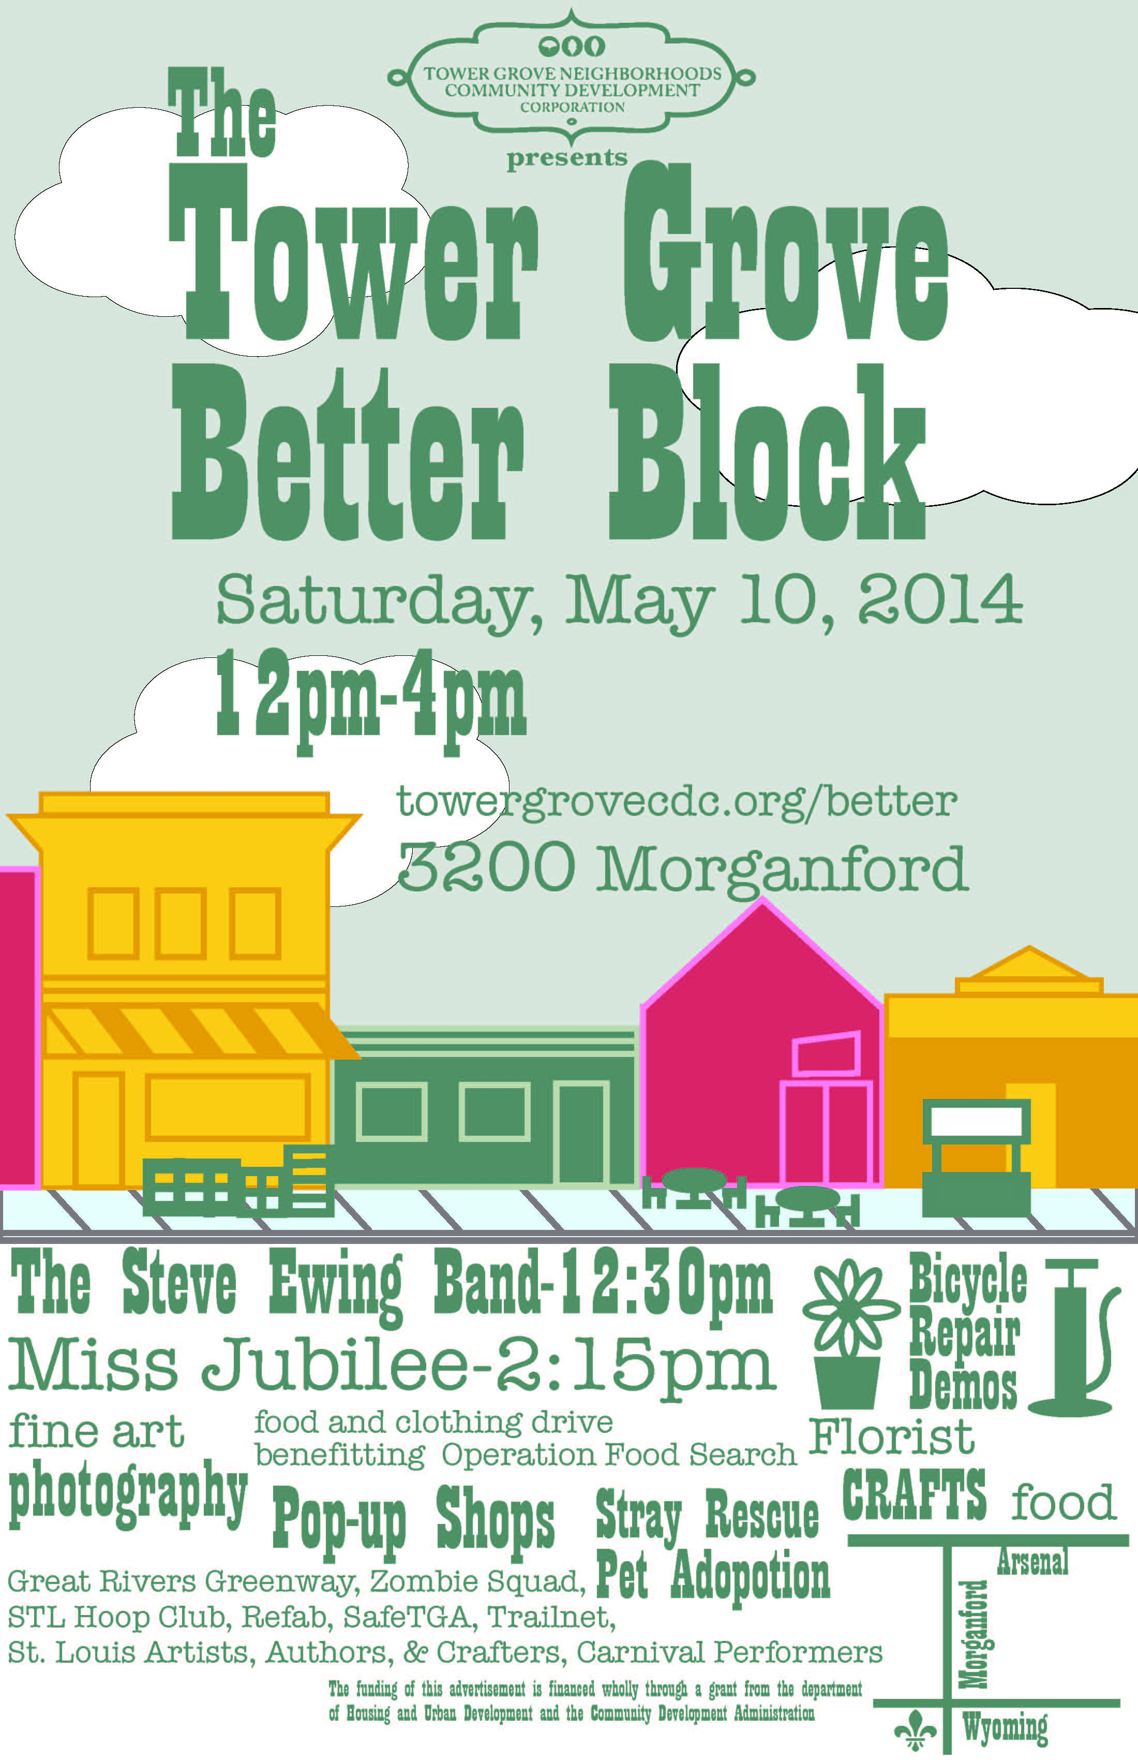
Entertainment:
Steve Ewing Band - performance
Miss Jubilee & the Humdingers - performance
STL Hoop Club - hoop dance performance
DuBourg Swing Dancers - swing dance performance
Vintage haberdashery - vintage fashion
Sustainability/Community Groups:
Stray Rescue- adoption event
Local Harvest- seed library, grocery & cafe
Isabee’s Beekeeping - bee keeping supplies
Refab STL – recycle/repurpose construction materials
Great River Greenway - Trails and greenways in STL
Safe TGA - Tower Grove Avenue bike advocates
Trailnet - Pedestrian, bike, and public transportation initiatives
Zombie Squad - Community building & disaster preparedness
Operation Food Search - canned food drive
Vendors:
Karmic Korner - soaps & teas
Rock n’ Roll Craft Show - local artisans/vendors
Skif International - clothing
Flora by Nora - florist
Cababi Bayoc - artist
Reece Forbes Photography - photographer
Jim Merkel - author
Mark S. Abeln - author
Food & Beverage:
Civil Life Brewery - local craft beer
Annie Moon’s - sandwiches, salads, baked goods
Restituo - iced coffees, smoothies

.
p. 2

